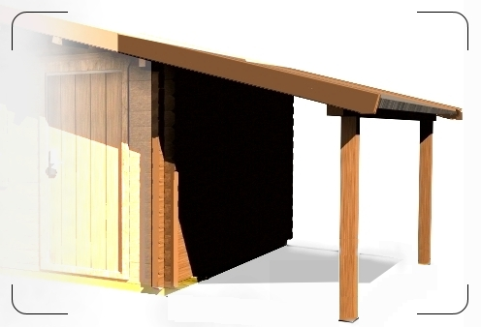

£161

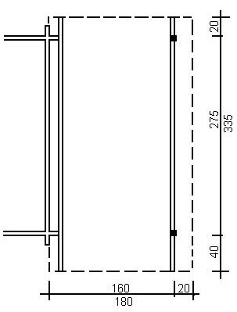
Consists of:

beam, attached to log cabin wall, other beam
is on two wooden pillars;
roof boards, storm protection beams.
Roof coating is not included in the price.
It is possible to join to log cabins T10, T12,
T14, T15, T17, T20, T23.

